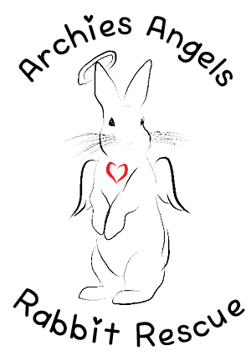
Archie’s Angels Rabbit Rescue
Adoption Request Form
Please be advised a home visit will be requested before adoption of the rabbit.
We reserve the right to refuse this application
Rabbit’s Name: _____________________________________________
Name of Applicant: _____________________________________________
Home phone: (____) ______________ Alternate phone: (____) _____________
Address: _______________________________________________________
City: ____________________ Province: ______ Postal Code: __________________
Email address: _________________________________
Have you ever kept a rabbit before? Yes No
If so, do you still have the rabbit? If not, why not?
_____________________________________________________________________________________
Where and how will the rabbit be housed? Please describe
______________________________________________________________________________________
______________________________________________________________________________________
How many people do you have living in your household? If there are children, please provide ages.
_____________________________________________________________________________________
_____________________________________________________________________________________
Do any family members have allergies? Yes No
The most important part of a rabbit’s diet is fresh hay. Is anyone in your family allergic to hay? Yes No
Do you own other pets? Yes No
Are they spayed/neutered? Yes No
Give breed, species, sex and age __________________________________________________________
___________________________________________________________
Do you have a regular veterinarian? Yes No
If yes, give his/her name and clinic #: ___________________________________________________________________
Please List two references that know you personally: Name, Number and Relationship
________________________________________________________________________________________
________________________________________________________________________________________
What will you do with your pet when you go on holidays? _________________________________________
What are your reasons for wanting to adopt a rabbit?
________________________________________________________________________________________________________________________________________________________________________________________
Who will be the primary caregiver for the rabbit?
____________________________________________________________________________________________
Does anyone in your household smoke? Yes No
Rabbits can be destructive (ie. Cable chewing, chewing furniture, digging, etc.). Are you prepared for these behaviors? How do you plan to prevent the rabbit from getting to hazards in your home?
____________________________________________________________________________________________________________________________________________________________________________________________________________________________________________________________________________________
Under what circumstances would you return this animal?
ʘ Moving ʘ New Baby ʘ Divorce ʘ New Relationship ʘ High cost of animal care ʘ Allergies ʘ Vacation
ʘ Aggression ʘ Retiring Other:___________________
Have you ever surrendered a pet to the SPCA or other organization in the past? ʘ Yes ʘ No , If yes please
Indicate reasons: ________________________________________________________________________
Have you ever been charged with neglect or cruelty to animals? Yes_________ No___________
Applicant Signature: ________________________________ Date: _____________________

